**PROJECT DOCUMENTATION**

COOKBOOK-YOUR VIRTUAL KITCHEN

1.Introduction

* **Project Title:** Cookbook-Your Virtual Kitchen
* **Team ID:** NM2025TMID30091
* **Team Leader: M.LIZY GRACY - 202400124@sigc.edu**
* **Team Member: G.SHREELEKHA - 202400783@sigc.edu**
* **Team Member: H.MANJU SRI - 202400309@sigc.edu**

**. Team Member: S.VERONIKA JOSHILA - 202400866@sigc.edu**

**. Team Member: T.SHARMILA - 202400801@sigc.edu**

# 2. Project Overview

• **Purpose:**

Cookbook is a recipe management and discovery platform. It allows users to post, edit, and explore recipes, filter by ingredients/cuisine, and generate shopping lists. • **Features:**

* Recipe posting and editing
* Recipe search & filtering by ingredients, cuisine, or category oFavorites collection oShopping list generator oComment and review system oAdmin dashboard for moderation

3. ArchitectureNM2025TMID29941

* **Frontend:** React.js with Bootstrap and Material UI
* **Backend:** Node.js with Express.js (API endpoints, authentication, recipe management)
* **Database:** MongoDB with Mongoose (for storing recipes, users, categories, favorites, comments)
* **Optional Services:** Cloud storage for recipe images (AWS S3/Cloudinary)

# 4. Setup Instructions

* **Prerequisites:**o Git o React.js oExpress.js oMongoose oVisual Studio Code oNode.js & MongoDB
* **Installation Steps:**
  1. Clone the repository:
  2. git clone https://github.com/your-repo/cookbook.git
  3. cd cookbook
  4. Install client dependencies:
  5. cd client
  6. npm install
  7. Install server dependencies:
  8. cd server
  9. npm install

# 5. Folder Structure

Cookbook/

│-- client/ # React frontend

│├── components/

│├── pages/

│└── assets/

│

│-- server/ # Node.js backend

│├── routes/

│├── models/

│├── controllers/

│└── middleware/

│

│-- package.json│-- README.md

# 6. Running the Application

* **Frontend:**
* cd client
* npm start
* **Backend:**
* cd server
* npm start
* **Access:**

Visit [http://localhost:3000](http://localhost:3000/)

# 7. API Documentation

* **User:**
  + POST /api/user/registeroPOST /api/user/login
* **Recipes:**
  + POST /api/recipes/createoGET /api/recipes/:id
  + GET /api/recipes/search?ingredient=tomato
* **Favorites:**
  + POST /api/favorites/addoGET /api/favorites/:userId
* **Comments:**
  + POST /api/comments/addoGET /api/comments/:recipeId

# 8. Authentication

* **JWT-based authentication** for secure login
* **Middleware** to protect private routes (recipe posting, favorites, reviews)

# 9. User Interface

* **Landing Page** – Recipe highlights & search
* **Recipe Details Page** – Full recipe with ingredients, steps, and reviews
* **User Dashboard** – Manage user’s recipes, favorites, and shopping list
* **Admin Panel** – Moderate recipes and manage users

# 10. Testing

* **Manual testing** at each development milestone
* **Tools:** Postman (API testing), Chrome DevTools (frontend testing)

11. Screenshots or Demo

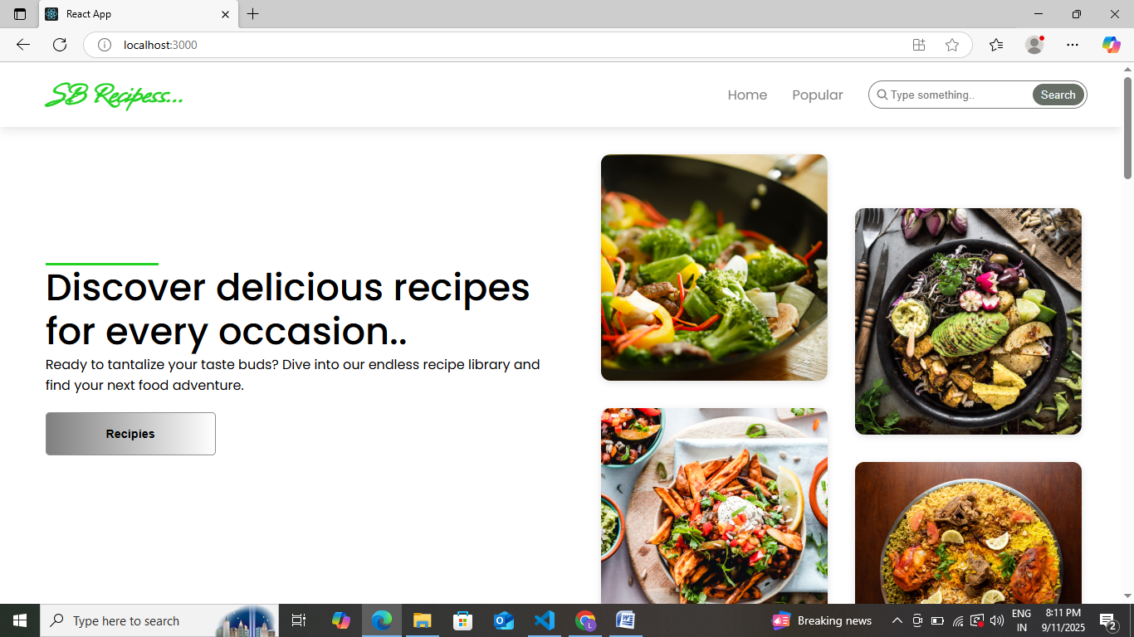

# 12. Known Issues

* Image upload may fail on low bandwidth
* Search speed decreases with very large dataset
* No offline support yet

# 13. Future Enhancements

* AI-powered recipe recommendations
* Nutrition calculator per recipe
* Voice-assisted cooking mode
* Mobile app (iOS/Android)